Physical Chemistry Chemical Physics

Volume 23
Number 24
28 June 2021
Pages 13421–13772
PCCP
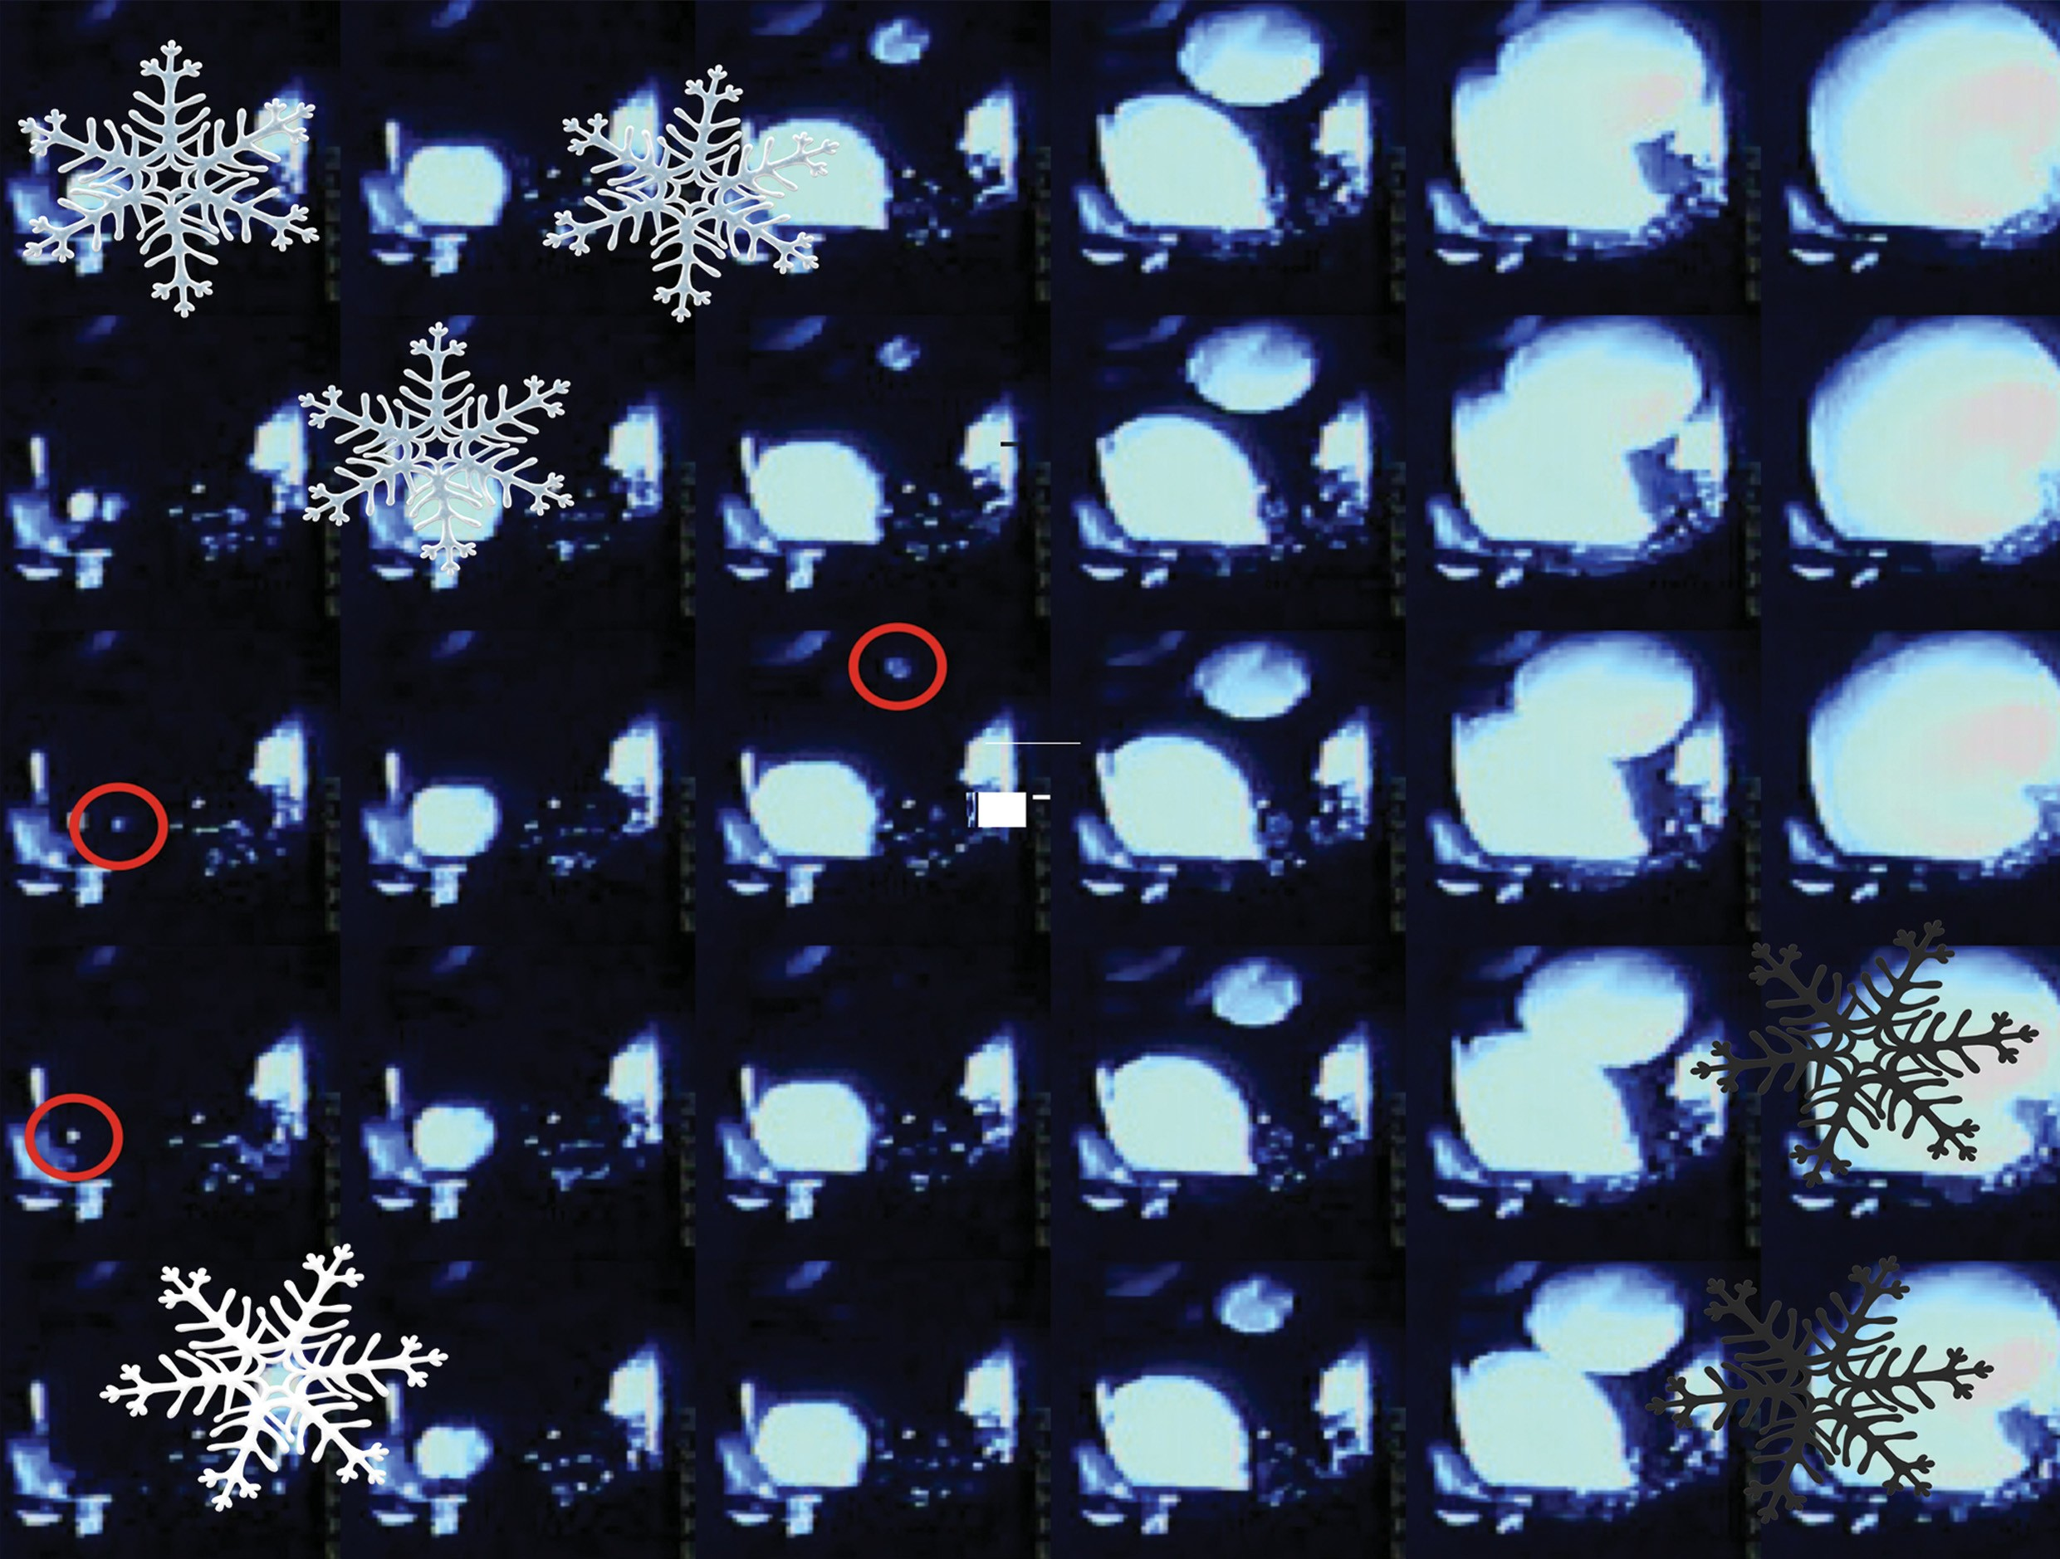
rsc.li/pccp

ISSN 1463-9076

PAPER
Matthew Szydagis, Cecilia Levy, Peter W. Wilson et al. Demonstration of neutron radiation-induced nucleation of supercooled water

PCCP
PAPER

Cite this: Phys. Chem. Chem. Phys., 2021, 23, 13440

Received 10th March 2021, Accepted 12th May 2021
DOI: 10.1039/d1cp01083b

rsc.li/pccp
Demonstration of neutron radiation-induced nucleation of supercooled water†

Matthew Szydagis, *ª Cecilia Levy, *ª Yujia Huang,ª Alvine C. Kamaha,ª Corwin C. Knight,ª Gregory R. C. Rischbieter ª and Peter W. Wilson *^{bc}

We present here direct evidence for neutrons causing nucleation of supercooled water. Highly purified water (20 nm filtration) is cooled to well below freezing (as low as -20 1C) with a radioactive calibration source of neutrons/gamma-rays either present or removed during each of many control cooling runs for
the same volume of water. When it is primarily neutrons irradiating the sample bulk, the non-equilibrium freezing point (also known as the ‘‘supercooling point’’) is, on average, +0.7 1C warmer than the control equivalent, with a statistical significance of greater than 5 Sigma, with systematic uncertainty included. This eﬀect is not observed with water in the presence of gamma-rays instead of neutrons. While these neutrons should have theoretically had suﬃcient energy to mount the energy barrier, corroborating our results, their raising of supercooling temperature has never been reported experimentally to the best of our knowledge. The potential to use deeply supercooled solutions, not only water, as metastable detectors for radiation and perhaps dark matter or neutrino physics presents now a new avenue for exploration.

Introduction
The heterogeneous nucleation of supercooled water and aqueous solutions continues to be the subject of study across diverse fields ranging from atmospheric physics¹ to cryobiology.² Nucleating particles and their eﬃciencies are well known for mineral salts,³ for crystals such as silver iodide,⁴ and for biological molecules such as the ice-nucleating proteins associated with, for instance, the bacterium Pseudomonas syringae.⁵ However, the eﬀects of neutrons and other radiation types on metastable water have not been studied in detail. While a priori expected, the question of whether such particles can directly cause some water molecules (H and/or O atoms) to gain suﬃcient kinetic energy to mount the energy barrier (if we are considering classical nucleation theory⁶) and therefore cause an irreversible nucleating event, has not been experimentally tested, to the best of our knowledge.
This lack of clarity around the eﬀects of irradiation upon supercooled water, especially for neutrons, is partly due to the inherent stochastic nature of nucleation and the fact that many freeze/thaw cycles are required on the same liquid sample. This repetition is required in order to have meaningful statistics on

ª The University at Albany, SUNY, Department of Physics, 1400 Washington Avenue, Albany, NY, 12222-0100, USA. E-mail: pwilson@kings.edu.au, mszydagis@albany.edu, clevy@albany.edu
^{b} School of Biological, Earth, and Environmental Sciences, University of New South Wales, NSW 2052, Australia
^{c} The King’s Institute, The King’s School, Parramatta, NSW 2151, Australia
† PACS numbers: 95.35.+d, 29.40.V, 29.40.-n, 25.40.Dn
the nucleation of that sample, within that container, both with/ without the potential nucleator (or anti-nucleator) in question. Perhaps the most well-accepted approach to analyzing nucleation statistics to date is that by Haymet and colleagues,^{7,8} who termed the experimental arrangement ‘‘ALTA,’’ which stands for Automatic Lag Time Apparatus, and who have looked at, as examples: the addition of crystals of AgI,⁹ stirring,¹⁰ coating the container with a hydrophobic surface,¹¹ and many other alterations which may aﬀect the nucleation of a sample of water
(and other aqueous solutions) in a given container.
To the best of our knowledge, the only references for radiation- induced nucleation of supercooled water are early works by Varshneya.^{12–14} However, familiarity with plotting survival curves (and skew-Gauss fits) of the nucleation events on a series of runs (in the way of ALTA) allows one to identify where the mean supercooling temperature (or so-called T₅₀) lies, and whether it is demonstrably different from a control when in the presence of, for instance, additives or of neutron sources, as described here. Perhaps the best demonstration of the power of the survival curve is the ‘‘Manhattan’’ of Heneghan et al., or the bubble or no-bubble plot (Fig. 4 in ref. 15).

Experimental setup
The concept is shown in Fig. 1, and the actual experimental setup is in Fig. 2. A fused quartz tube, ultrasonically cleaned within an ISO3 cleanroom, was prepared with 22 ± 1 grams of water, then fully submerged in a thermoregulation ethanol

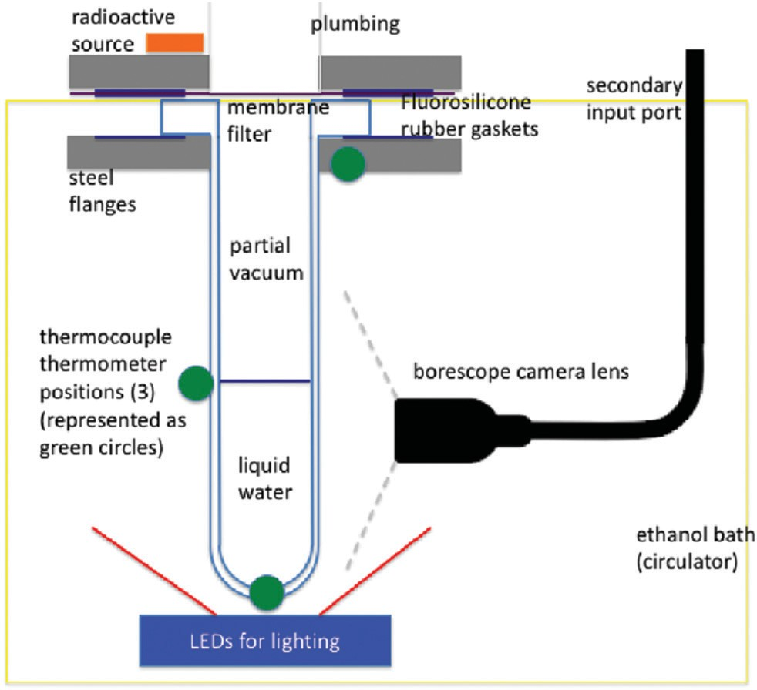
Fig. 1 Diagram of setup, the core of which was one 10 cm-long, cylindrical quartz tube (left) with inner diameter of 3.55 cm, outer 4.20 cm, and hemispherical bottom.

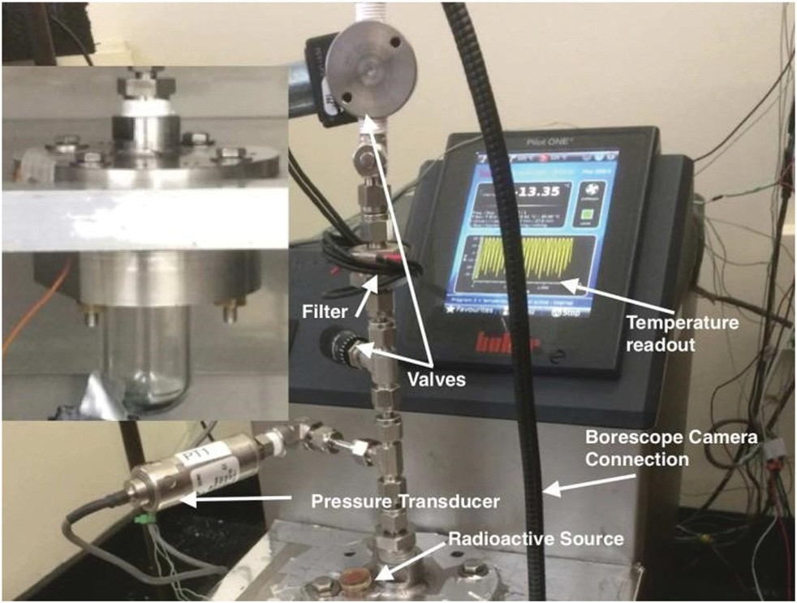
Fig. 2 Photo of setup during operation. Left inset is quartz tube contain- ing 22 mL of purified water.

bath set over vibration-dampening pads and instrumented with three thermocouples for the recording of exothermic increases on freezing. These were attached near the top, the middle (water line), and the bottom (hemisphere). Supplementing these 3 thermometers, a fourth one, whose variation had no discernible eﬀect, recorded room temperature. LEDs provided illumination from below while a borescope provided images.
Purity of the water is of importance to minimize the temperature when heterogeneous nucleation occurs, where eliminating potential nucleation sites such as dirt and other particulates leaves only the wall of the container as the source of nucleation. It should be noted that heterogeneous nucleation will always occur upon a two- dimensional surface, rather than within three dimensions,
which would be homogeneous and occurs at -40 1C,^{16,17}
except perhaps in the case where an incident neutron causes a water molecule to mount the energy barrier (an idea developed in this work).
Deionized water was distilled through a 20 nm porous filter membrane into a quartz tube evacuated via an oil-less pump. Note this small-diameter filter required a very long process (months) in order to force the water through. The water was cooled in an ethanol bath until it reached a supercooled state, at which point an incident particle could theoretically cause the phase transition.
The water was continuously cooled at a mean rate of 1.90 ±
0.05 1C min⁻¹, which likely caused temperature non-uniformity
which slowed nucleations. The data were taken both with and without a fission neutron source, i.e., ²⁵²Cf, which produces a wide spectrum of n’s with typical energies O(1–10) MeV.¹⁸ Its overall activity was 1.0 mCi, leading to 3000 n s⁻¹.¹⁹ Subsequent (one year later) data was also taken both with
and without a gamma ray source of ¹³⁷Cs. Data were taken in runs, with each run containing several data sets, alternating control and source data, to minimize systematics. A run always included at least one control data set, and only included data from 1 source at the same location (for instance, a run was alternation of control–Cf–control–Cf–control data sets). Each data set is either 2 day-long or 1d-long, and consists of several tens of individual events. An event was defined as a freezing of the liquid, as the freezing event is still rapid for deeply super- cooled water, when compared to the time spent supercooled.
Approximately equal numbers of data sets with a source vs. none (control) were collected across day and night. Beginning at 20 1C, 1 cool-down took about 30 minutes (slope indicated in Fig. 3). The thermo-regulator was set so that the climb to 20 1C was 30 minutes as well, to set up the next 1 hour-long cycle.
The initial data analysis was based on studying two para- meters: the temperature T_{min} at which the freezing event occurred, and the time Dt_{active} that the water had spent in a
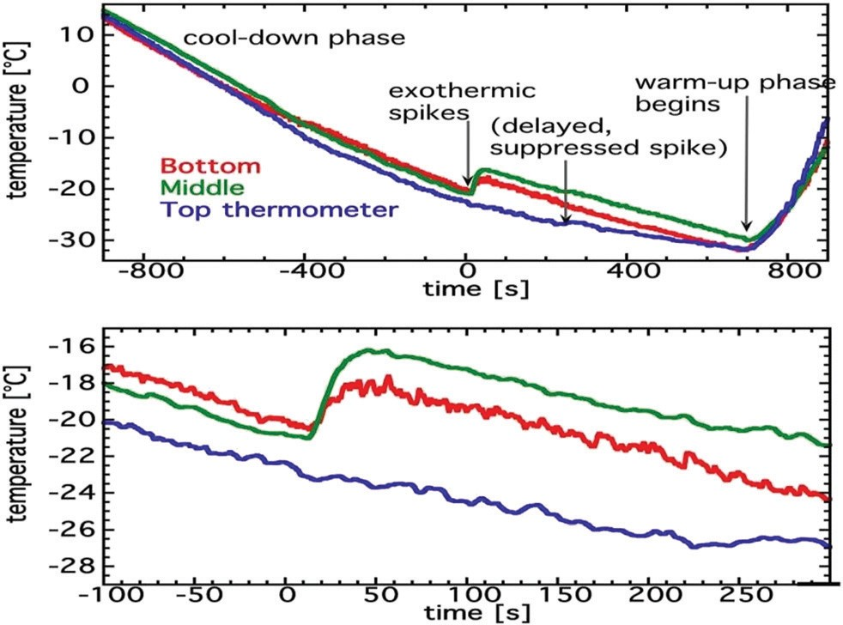

Fig. 3 Top The temperature profile for a typical event. Bottom Zoomed- in version near t = 0. The exothermic rise at nucleation (and the subse- quent freezing) can be clearly seen in the green and red traces from two diﬀerent thermometers. The blue trace is from a thermometer placed some distance from the sample, at the top of the tube.

supercooled state (given approximately linear cooling, these should be equivalent). More precisely, Dt_{active} is defined as the time interval between -15.5 1C and when freezing occurs, with
-15.5 1C selected as the higher temperature border above
which no nucleation is observed (see Fig. 4). This analysis was then refined into the more traditional S-curve style of ALTA, eﬀectively summarizing all of the important data more concisely. The survival, or ‘‘S,’’ curve shows unfrozen fraction as a function of temperature (black and yellow lines in Fig. 4 left). The T₅₀’s are then the temperatures at which the sample had frozen 50% of the time.
Dt_{active} Has the advantage of the moment of freeze being visually verifiable, but the disadvantage of still relying on T for defining the start time. T’s were always measured outside the quartz to avoid nucleation, leading to a universal 2.5 1C oﬀset at the cooling rate set, already added to all of the values reported here, control and source alike, increasing them compared to what was actually measured. This renormalizing oﬀset was determined by viewing the plateau in T in the top thermocouple during melting, consistently occurring at 2.5, not 0.0 1C (where, during melting, the oﬀset had the opposite direction with the sample colder than measured, due to the thermal lag during heating). All three thermocouples were also cross-calibrated against the built-in RTD of the chiller. Lastly, the thermo- couples reacted diﬀerently based on location. We minimize that last systematic in the choice of the top for defining minimum temperatures, for the purpose of a greater consistency amongst runs, as it was the only thermometer never requiring reattachment, thus making it most consistent despite it being furthest from the water and reacting the weakest/latest (Fig. 3, blue). Camera images were used to determine and verify the correct event time, to determine the best time to use for pulling a recording of temperature from the top thermometer.
In order to mitigate any systematic eﬀects of any inherent stochastic changes during the data-taking, like in the cooling rate, we compute the statistical significances of any source data with respect to control by considering only control sets from within the same one run, immediately preceding and/or following the source sets.

Results
When the ²⁵²Cf neutron source was present, water did not remain supercooled as long, on average, over multiple cool-downs. Accordingly, freezing occurred at warmer minimum tempera- tures T_{min}, as indicated by a +5.8s diﬀerence in raw median, and +5.2s diﬀerence in T₅₀ (the temperature at which the freezing had occurred 50% of the time across all data sets in the run) between ²⁵²Cf vs. control data sets. All T₅₀’s are derived from an error function erf (Gaussian integral) fit, most common in the field. The eﬀect can be seen in Fig. 4 left. At right, skew-Gaussian and normal Gaussian fits to the raw data and the unbinned population mean are all explored as cross-checks. For control, a skew fit is superior, consistent with past supercooled water data,⁸ but standing in contrast with the neutron data. Statistical errors are based upon combining all data points of one type from the same run and calculating the population standard deviation divided by the square root of the number of events included from all data sets within the one same run.
Systematic error in temperature is conservatively determined
by the deviation in the median T_{min}’s across a calendar year of 4800 control events, with individual data sets defined by 24 or 48 h long collections of events. This was computed by first subtracting the medians of the control values from all of the control values, by run, to centrally renormalize all of the data.

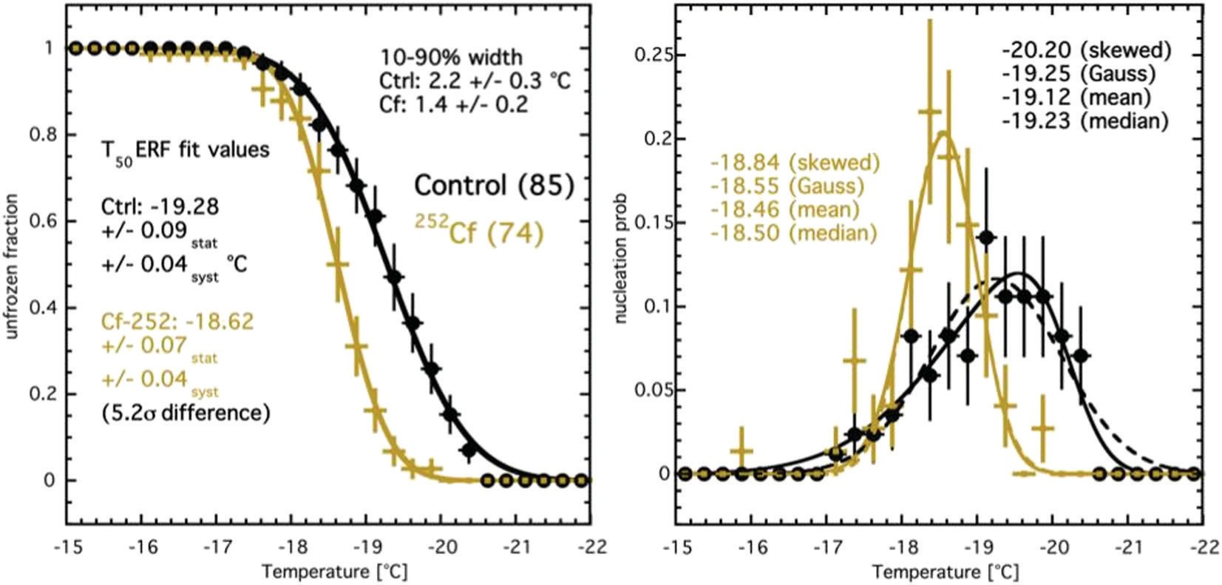
Fig. 4 (left) All ²⁵²Cf data (74 events) in yellow, and control data from the same period of time (85 events) in black. For control, only the data immediately before, after, and between Cf data is used. x-Errors are bin widths (0.25 1C) while y-errors are statistical only (Poisson). T₅₀’s (-19.28 and -18.62) quoted are the T’s at which the sample had frozen 50% of the time, based upon the smooth error-function fits, solid lines. The FWHM’s of skew fits are
comparable to the 10–90% widths of the survival curves fit by erf’s. (right) Skew solid and Gaussian dashed, each different for control but very similar for Cf, with Cf’s skewness parameter a = 1.0 ± 0.9, thus consistent with zero (for control, a = 3.4 ± 1.1).

This is followed by computing the standard error, defined as for statistical error. Choice of median over, for example, skew- Gaussian centroid, is motivated by it being less biased, by not being subject to the choice of binning, nor assumptions on shape. Medians are also less aﬀected by extreme outliers that could dramatically shift arithmetic means. No data are cut.
In addition to T₅₀, the 10–90% widths of the survival curves are also of interest. Previously, Wilson and Haymet²⁰ have shown that with sufficient runs on the same sample the 10–90 width seems to converge to 0.72 1C. Our control exhibits 2.2 1C, suggesting more than one nucleation site within the glass con- tainer and water volume, and/or a nucleation site that changes over time. Both hypotheses are valid according to a visual analysis of data, both control and source (Fig. 5). The irradiated runs show a narrower width, 1.4 1C, and as this nucleation mechanism is by direct momentum transfer likely to the water in the bulk (rather than directly to water momentarily at the glass surface) and to different water molecules by event, the difference and the overall effect certainly warrant further investigation (but beyond the scope of this paper). The narrowing may be due to more events at the same/similar locations, close to the source.
Space constraints in the thermo-regulating chiller forced us to have only one camera, thus making three-dimensional position reconstruction impossible. As a result, any quantitative con- clusions from images is forced to wait until future work when it should be possible to determine surface versus bulk events more readily and thus heterogeneous versus homogeneous nucleation, using a minimum of two cameras oﬀset in angle, and any diﬀerences between control and source and/or between single- and multiple-scattering. Nevertheless, as demonstrated in Fig. 5 as a sample, our proof-of-concept preliminary work presented here is suﬃcient for concluding that multiple sites were indeed active, both spatially and temporally.
Despite a formal image analysis lacking at this time additional confirmation of the primary result was still possible, via the breakdown of the Cf run into individual data sets, in Fig. 6.
The significance of the diﬀerence when Cf is compared with itself, control to itself, then Cf compared to control is respectively 1.6, 1.5, and 4.7s based on the diﬀerence in the medians displayed in Fig. 6, divided by all statistical and systematic uncertainties summed in quadrature. As expected, based upon the survival curve diﬀerences (Fig. 4), source data are self-consistent, control is self- consistent, but ²⁵²Cf diﬀers from control, significantly, despite

being tested under identical conditions except for the source.
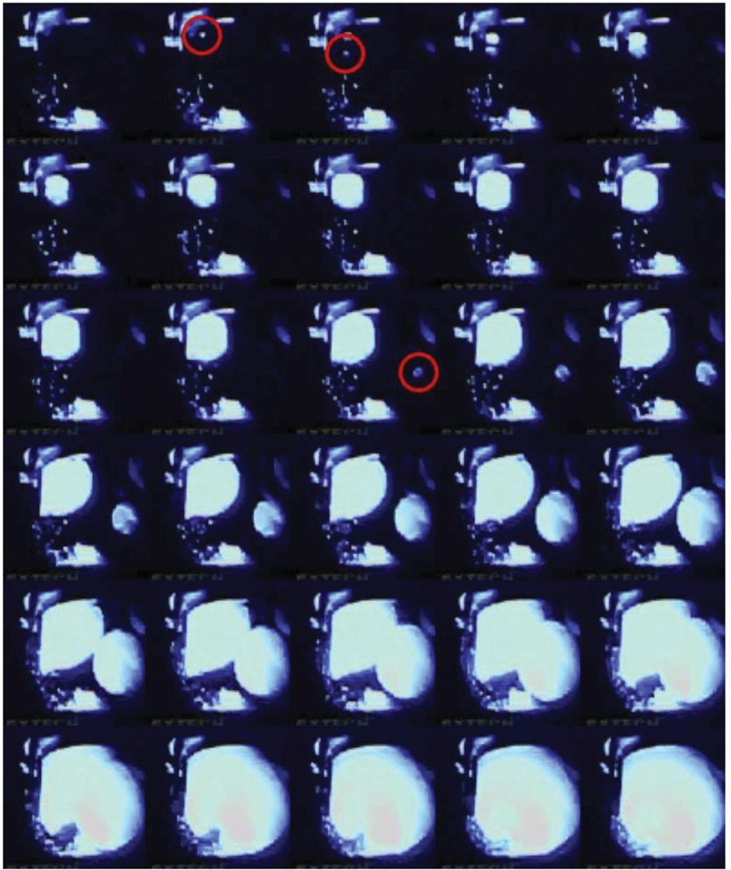
It is helpful for potential future applications to identify whether neutrons or gammas interacted with the water molecules/ atoms/nuclei. In an attempt at distinguishing neutron- vs. gamma- induced freezing, the Cf data were taken with Pb shielding. With ²⁵²Cf, neutrons are being directly emitted from spontaneous fission; these neutrons are accompanied by a high flux of secondary gammas that are up to several MeV in energy.²¹ Varshneya and

Fig. 5 An example of one possible triple-nucleation event in neutron data. Red circles indicate the first frames in which a nucleation site appears. The first two snowballs merge rapidly, but a 3rd appears much later, implying that it is from a distinct neutron. Unlike in a bubble chamber there is no pressure increase activated post trigger so any unfrozen volume remains active during an ongoing event. For brevity, only every 3rd frame is pictured, that is, every 150 ms. Due to the large volume, thermal gradients were likely present in both control and source data, causing this slow freezing, visibly taking seconds, but having no impact on the actual result of the experiment.

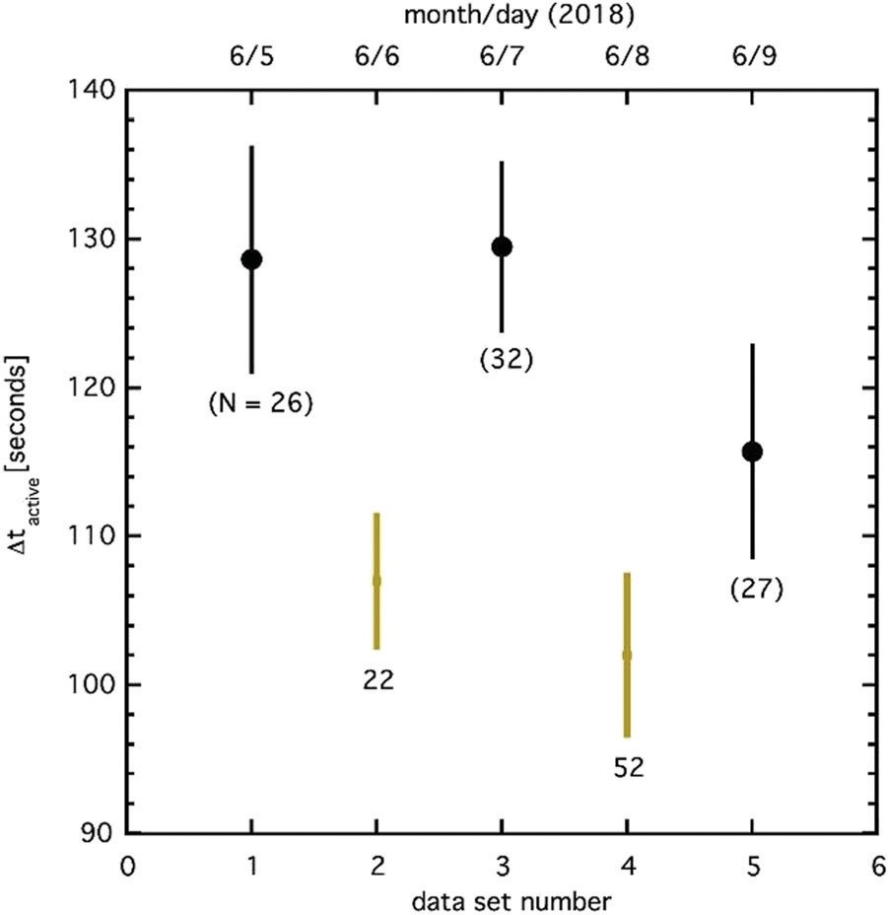
Fig. 6 Control data sets for the five-day period when all ²⁵²Cf data were taken, demonstrating the time spent active by the water in both control sets and ²⁵²Cf sets. The number in parentheses is the number of nuclea- tions for each data set. The shorter time to nucleation (so, the warmer temperature of nucleation) is evident for Cf (yellow) vs. control (black). Medians are displayed with no fits here of any kind.

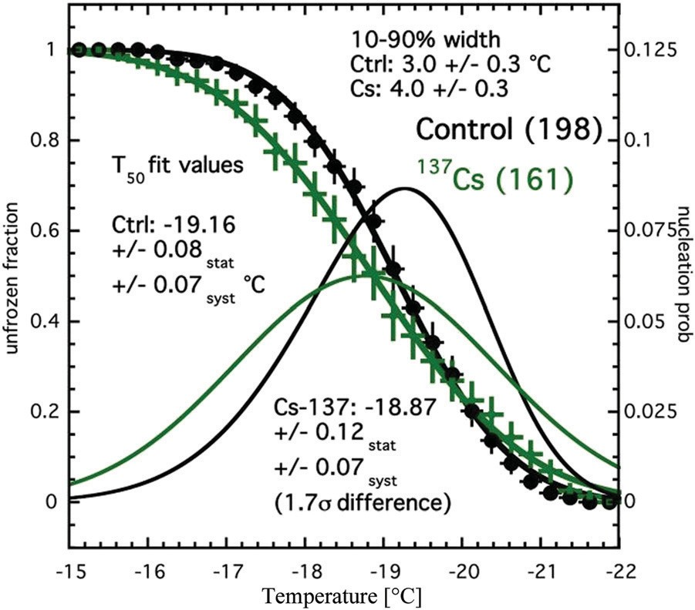
Fig. 7 ¹³⁷Cs data in green with nearest control black. Skew fits, combined here into a single plot, were chosen as best fitting raw data prior to integration into the ‘S’ fits (erf) but are mainly visual guides and cross- checks of nucleation probability. As with Cf, skewness is close to 0 for
source data. Temperatures (-19.16 and -18.87) cited are T₅₀’s, and based
on the common-use survival-curve error functions alone.
properties of supercooled water before²⁵ they have not been used to solidify it as we do here. The 2018 Cf run was most distinctive from the control (source removed) at a maximum of
5.8s in terms of median T_{min} and a minimum of 4.7s in terms of a systematic alternation with control combining the results of both T_{min} and t_{active}, in our most conservative analysis. The statistical significance according to the traditional survival- curve analysis was between at 5.2s. The gamma-ray data were discrepant from control at 1.7s only, suggesting neutrons and gammas aﬀect supercooled water disproportionately, with neutrons much more likely to be responsible for increased nucleation probability measured in this work. We nonetheless did explore the possibility that, e.g., gamma-rays from increased n-capture on hydrogen were responsible for the eﬀect we observed in the Cf, but find it not likely, due to the much lower rate compared to other interactions, according to GEANT4.
We note that these results, while significant, are not entirely unexpected. According to both G4 MC sims, as well as simple 2-body 3D collision kinematics, given incoming neutron kinetic energies in the 1 MeV range, the median energy of recoil for hydrogen nuclei was 100 keV from Cf neutrons and 50 keV for

oxygen. This is well above the threshold energy described in
Khvorostyanov and Curry,³⁷ indicating that nucleation should be

the theoretical work of others following him including Pisarev’s²² concluded that gammas are more likely to be responsible for water nucleation, not neutrons. Our final analysis we present is thus intended for addressing this possibility, that the gammas not neutrons from the ²⁵²Cf were responsible for the strong eﬀect that we have unequivocally observed. Separated from the Cf by 1 year, the diﬀerent control data here (Fig. 7) are also indicative of the long-term stability of our setup.
While Fig. 7 is ambiguous, compared with earlier results especially, its very ambiguity is telling: even though the gamma energies (661.66 keV) from the ¹³⁷Cs source (10 mCi, i.e., 370 000 gammas per second) were lower than from the Cf source, its gamma interaction rate was over two orders of magnitude higher in the water than either the gamma or the neutron interaction rate of the ²⁵²Cf according to full GEANT4 simulations²³ of the setup (G4 is a standard Monte Carlo simulation software tool used for high-energy physics experiments that can account for shielding/ geometry). While the diﬀerence for the gamma-rays is in the same direction (a higher temperature) as for the Cf it is much less significant, and the Cs curve, based on 161 events, even crosses control’s ‘S’ based on the 198 closest in time (as done for Cf earlier). It is not as disjoint if compared with Fig. 4. When the systematic uncertainty is included the statistical significance of the diﬀerence from control is merely 1.7s and can thus not be robustly ruled out as being merely statistical fluctuation. The width is even larger than control, a possible sign of gammas adversely aﬀecting thermocouples directly and causing the tem- perature measurement to be less reliable.²⁴

Discussion
To the best of our knowledge the Cf eﬀect we record has never been reported. While neutrons have been used to study the
expected from the interaction of neutrons in supercooled water, provided suﬃcient energy is deposited within the critical radius.
In addition, due to the order of magnitude higher stopping power (or diﬀerential energy deposition) dE/dx from neutrons recoiling against H or O nuclei as opposed to gamma-rays predominantly recoiling from electrons, according to simple Bethe-Bloch calculations, it would be less likely that gamma- rays led to the freezing instead of neutrons, especially if this work with supercooling is analogous to superheating as in bubble chambers.²⁶ This corroborates our findings.
There is no analysis method presented which leads to a statistical consistency between ²⁵²Cf and control, underscoring the robustness of these results. We acknowledge however that much remains to be studied. The setup needs to be recon- structed with improvements and more data taken with an even greater variety of sources both neutron and gamma, at diﬀerent distances, with diﬀerent amounts and types of shielding (Pb for gammas and polyethylene for neutrons). A detailed analysis of scattering cross-sections, and the momentum conservation and kinetic energy transfer required for nucleation at any given temperature is beyond the scope of this initial report, and will be the subject of subsequent publications. An improved Monte Carlo simulation and modelling of the setup is underway for determining the energy threshold, as well as minimum stopping power or linear energy transfer also known as diﬀerential energy deposition (or just dE/dx) required to trigger a nucleation.

Conclusion
Our paper documents preliminary evidence MeV-scale neutrons cause nucleation of supercooled water.²⁷ A 5s diﬀerence from control was measured for a ²⁵²Cf n source. This very promising

first result opens up the possibility of employing this technology as an underground experiment which seeks nuclear recoils from the theoretical dark matter particle,²⁸ thought to behave just as a neutron in terms of elastic nuclear scattering.²⁹ We’re encouraged by the initial results that seem to constitute observation of a previously undocumented eﬀect in water, to further develop this technology. If the energy threshold is indeed in the keV regime,
this technology could be particularly well-suited to a search for low-mass (sub-GeV c⁻² rest-mass energy) dark matter.³⁰ For that
search, the challenges are similar to those faced in measurements of coherent elastic neutrino-nucleus scattering.³¹ If there is some sensitivity to e⁻ recoils, as from gammas, then neutrino-electron
interactions in water³² may also lead to freezing, but this appears
to be less likely.
Potential applications of a particle detector based on super- cooled water are even more interdisciplinary. It is germane to atmospheric science,³³ where conflicting claims of radiation causing nucleation vs. not^{1,34} may be resolvable by appeal to diﬀerent dE/dx. Controlling the temperature and/or pressure allows one to control the critical radius, and thus the particle detection thresholds for both energy³⁵ and dE/dx,³⁶ which provides ability to make the detector insensitive (or, selective) to distinctive particle interactions. As the supercooled temperature is lowered, each of the detector response thresholds should be correspondingly lowered. Lower temperatures than reported here should be possible with a greater degree of purification, via use of existing technologies. We coin the term ‘‘snowball chamber’’ to describe the new device, due to spherical ice growth following nucleation(s), the snow- like qualities of the ice produced, and lastly the snowballing exothermic reaction whereby an entire volume freezes from only a single initial interaction.

Data availability
Data in support of the findings of this study are available from the corresponding authors on reasonable request.

Conflicts of interest
There are no conflicts of interest to declare.

Acknowledgements
This work was supported by the University at Albany, State University of New York (SUNY), under new faculty startup funding provided to Prof. Szydagis for 2014–2018, and under the Presidential Innovation Fund for Research and Scholarship (PIFRS) grant awarded to Prof. Szydagis for 2017–18 by the Office of the Vice President for Research, Division of Research, the University at Albany, SUNY, as well as with a FRAP-A award (Faculty Research Award Program ‘A’) and the startup funds of Prof. Levy. The research was partially supported by the Department of Energy under Award No. DE-SC0015535, allowing R&D part-time. We thank Dr Aleksey Bolotnikov of
Brookhaven National Laboratory for making us aware of pre- vious works, by Pisarev and by Varshneya.
We also gratefully acknowledge the advice, encouragement, and support from the following individuals, who provided their knowledge and their expertise: our UAlbany colleagues Prof. Saj Alam and Prof. Bill Lanford. We thank Dr Marc Bergevin of Livermore National Lab for helpful discussions on the relative merits of AmBe versus ²⁵²Cf sources. Lastly, Szydagis wishes to personally thank his wife Kel, a linguist not physical chemist by training, for suggesting the filter to use for purification, and coining the name.

References
- L. H. Seeley, G. T. Seidler and J. G. Dash, Laboratory investigation of possible ice nucleation by ionizing radia- tion in pure water at tropospheric temperatures, J. Geophys. Res.: Atmos., 2001, 106, 3033–3036.
- H. Huang, M. Haishui, M. Yarmush and O. B. Usta, Long- term deep-supercooling of large-volume water and red cell suspensions via surface sealing with immiscible liquids, Nat. Commun., 2018, 9(1), 3201.
- P. Conrad, G. E. Ewing, R. L. Karlinsey and V. Sadtchenko, Ice nucleation on BaF₂(111), J. Chem. Phys., 2005, 122, 064709.
- C. Marcolli, B. Nagare, A. Welti and U. Lohmann, Ice nucleation eﬃciency of AgI: review and new insights, Atmos. Chem. Phys., 2016, 16, 8915–8937.
- L. R. Maki, E. L. Galyan, M.-M. Chang-Chien and D. R. Caldwell, Ice Nucleation Induced by Pseudomonas syringae, Appl. Microbiol., 1974, 28, 456–459.
- D. W. Oxtoby, Nucleation of first order phase transitions,
Acc. Chem. Res., 1998, 31, 91–97.
- P. W. Wilson and A. D. J. Haymet, Eﬀect of solutes on the heterogeneous nucleation temperature of supercooled water: an experimental determination, Phys. Chem. Chem. Phys., 2009, 11, 2679–2682.
- A. F. Henaghan, P. W. Wilson, G. Wang and A. D. J. Haymet, Liquid-to-Crystal Nucleation: Automated Lag-Time Apparatus to study supercooled liquids, J. Chem. Phys., 2001, 115, 7599.
- A. F. Heneghan, P. W. Wilson and A. D. J. Haymet, Statistics of heterogeneous nucleation of supercooled water, and the eﬀect of an added catalyst, Proc. Natl. Acad. Sci. U. S. A., 2002, 99, 9631–9634.
- P. W. Wilson and A. D. J. Haymet, The eﬀect of stirring on the heterogeneous nucleation of water and of clathrates of tetrahydrofuran/water mixtures, Condens. Matter. Phys., 2016, 19(2), 23602, Festschrift. preprint arXiv:1603.07126.
- A. F. Heneghan, H. J. Moore, T. R. Lee and A. D. J. Haymet, Statistics of eterogeneous nucleation of supercooled aqu- eous solutions in a self-assembled monolayer-coated con- tainer, Chem. Phys. Lett., 2004, 385(5–6), 441–445.
- N. C. Varshneya, Detecting radiation with a supercooled liquid, Nature, 1969, v223(08), 826–827.
- N. C. Varshneya, On the principle of a radiation detector,
Univ. Roorkee Res. J., 1965, 8, 1.

- N. C. Varshneya, Theory of radiation detection through supercooled liquid, Nucl. Instrum. Methods, 1971, 92(1), 147–150.
- A. F. Heneghan and A. D. J. Haymet, Liquid-to-crystal hetero- geneous nucleation: bubble accelerated nucleation of pure supercooled water, Chem. Phys. Lett., 2003, 368(1–2), 177–182.
- J. D. Atkinson, B. J. Murray and D. O’Sullivan, Rate of homogenous nucleation of ice in supercooled water,
J. Phys. Chem. A, 2016, 120(33), 6513–6520.
- C. Goy, et al., Shrinking of rapidly evaporating water micro- droplets reveals their extreme supercooling, Phys. Rev. Lett., 2018, 120, 015501.
- NIST, http://nucleardata.nuclear.lu.se/toi/nuclide.asp? iZA = 980252, 2020.
- E. Aprile, et al., Design and performance of the XENON10 dark matter experiment, Astropart. Phys., 2011, 34, 679–698.
- P. W. Wilson and A. D. J. Haymet, The spread of nucleation temperatures of a sample of supercooled liquid is indepen- dent of the average nucleation temperature, J. Chem. Phys. B., 2012, 116(45), 13472.
- C. E. Dahl, The Physics of Background Discrimination in Liquid Xenon, and the First results From XENON10 in the hunt for WIMP dark matter, PhD thesis, Case Western Reserve University, 2009.
- A. Pisarev, ‘‘On ion detection in supercooled liquids’’ CERN- TRANS-67-7 (1967); A. Pisarev, ‘‘New Ideas for Tracking Cameras,’’, Phys. Elem. Part. At. Nucl., 1972, 3(3), 650–687.
- S. Agostinelli, et al., ‘‘Geant4 – A Simulation Toolkit,’’, NIM A, 2003, 506, 250–303; J. Allison, et al., ‘‘Geant4 Developments
and Applications,’’, IEEE Trans. Nucl. Sci., 2006, 53(1), 270–278.
- G. J. Dau, R. R. Bourassa and S. C. Keeton, Nuclear radiation dose rate influence on thermocouple calibration, Nucl. Appl., 1968, 5(5), 322–328.
- R. Schiller and I. Kules, Radiation chemistry of supercooled water, J. Phys. Chem., 1971, 75(19), 2997–2999.
- C. Amole, et al., Dark matter search results from the PICO- 60 C3F8 bubble chamber, Phys. Rev. Lett., 2017, 118, 251301;
E. Behnke, et al., First Dark Matter Search Results from a 4 kg CF3I Bubble Chamber Operated in a Deep Underground Site, Phys. Rev. D, 2012, 86(5), 052001[Erratum: Phys. Rev., D90(7), 2014, 079902.].
- D. Barahona, Thermodynamic derivation of the activation energy for ice nucleation, Atmos. Chem. Phys., 2015, 15, 13819–13831; D. Barahona, On the thermodynamic and kinematic aspects of immersion ice nucleation, Atmos. Chem. Phys., 2018, 18(23), 17119–17141.
- C. McCabe, The Astrophysical Uncertainties of Dark Matter Direct Detection Experiments, Phys. Rev., 2010, D82, 023530.
- M. Battaglieri, et al., U. S. Cosmic Visions: New Ideas in Dark Matter 2017: Community Report, in U. S. Cosmic Visions: New Ideas in Dark Matter College Park, MD, USA, 2017.
- E. Aprile, et al., (XENON1T Collaboration) ‘‘A Search for Light Dark Matter Interactions Enhanced by the Migdal Eﬀect or Bremsstrahlung in XENON1T,’’, Phys. Rev. Lett., 2019, 123, 241803.
- D. Akimov, et al., Observation of coherent elastic neutrino- nucleus scattering, Science, 2017, 357(6356), 1123–1126.
- S. Fukuda, et al., The Super-Kamiokande Detector, Nucl. Instrum. Meth. A, 2003, 501(2), 418–462.
- F. Yu, Formation of large NAT particles and denitrification in polar stratosphere: possible role of cosmic rays and eﬀect of solar activity, Atmos. Chem. Phys., 2004, 4(9/10), 2273–2283.
- E. M. Dunne, et al., Global atmospheric particle formation from CERN CLOUD measurements, Science, 2016, 354(6316), 1119–1124.
- E. Behnke, et al., Direct measurement of the bubble- nucleation energy threshold in a CF₃I bubble chamber, Phys. Rev. D, 2013, 88, 021101.
- F. Seitz, On the Theory of the Bubble Chamber, Phys. Fluids, 1958, 1, 2–13.
- V. Khvorostyanov and J. Curry, The Theory of Ice Nucleation by Heterogeneous Freezing of Deliquescent Mixed CCN. Part I: Critical Radius, Energy, and Nucleation Rate, J. Atmos. Sci., 2004, 61, 2676–2691.

